
CAMBRIDGE UNIVERSITY LADIES NETBALL CLUB WELFARE POLICY
Aims
Cambridge University Ladies Netball Club (CULNC) regards the health, safety and welfare of all members to be of paramount importance. The fundamental basis for our welfare policy is the desire to treat our athletes responsibly, with respect and to support them in their pursuit of both academic and sporting goals. The Club recognises that welfare is not just about safety on the court but covers the full breadth of Club activities from training and competition through to socials and our media presence.
To this end, CULNC aims to ensure, so far as is reasonably practicable, that policies, procedures and practices are in place to maintain a safe and healthy environment and promote a positive club culture, not only for its members but also for other people and organisations that may be affected by the activities of the Club.
ROLES AND RESPONSIBILITIES
Everyone involved in the club, regardless of whether they are a participant, committee member, coach, volunteer or spectator is expected to:-
- Respect the rights, dignity and values of others;
- Operate within the rules of the sport.
- Treat facilities, staff and students at the University of Cambridge and other institutions with respect and abide by any rules that may apply;
- Be aware of how their actions may be perceived by others;
- Maintain high standards of personal behaviour at all times;
- Conduct themselves in a reasonable manner relating to offensive language and temperament
- Refrain from any form of bullying or harassment of others. Harassment is any offensive conduct based on a person`s race, sex, gender identity, national origin, colour, disability, age, sexual orientation, marital status, religion or any other status protected by law.
- Respect the decisions of officials, making all appeals through the appropriate formal process and respecting the final decision;
- Not condone, or allow to go unchallenged, any form of bullying, harassment or discrimination if witnessed;
- Refrain from the use of and involvement with illegal substances at all times.
- Not act in an unlawful manner;
- Not encourage or pressure others into acting against the code;
- Understand the repercussions of any breaches of this Code of Conduct.

THE CLUB COMMITTEE
Overall responsibility for the management of welfare within CULNC rests with the Club Committee. As such, the Committee will aim, as far as is reasonably practical, to:-
- •    Create, promote and maintain an equitable, safe and positive environment for all club members to participate and/or compete in their sport.
- •    Develop, implement and monitor policies, procedures and codes of conduct that are suitable for the club environment and that these are well publicised and/or formally endorsed by the relevant individuals and/or governing bodies.
        - •    Ensure that there is at least one competent Welfare Officer designated within the club to take the lead role in dealing with welfare matters;
- •    Ensure that there is at least one competent Safety Officer or person designated within the club to take the lead role in health and safety policies, procedures and practices.
- •    Ensure that coaches, instructors, officials and other student athlete support services provided, or endorsed, by the Club are at a suitable level for the activities that they run and the skills and abilities of members.
- •    Support Whistle Blowing and take steps to ensure members feel able to raise concerns without fear of negative repercussions;
- •    Ensure that confidentiality is maintained in relation to concerns and referrals, and information is only shared on a genuine ‘need to know’ basis;

- Club Welfare Officer

Name: India Foster
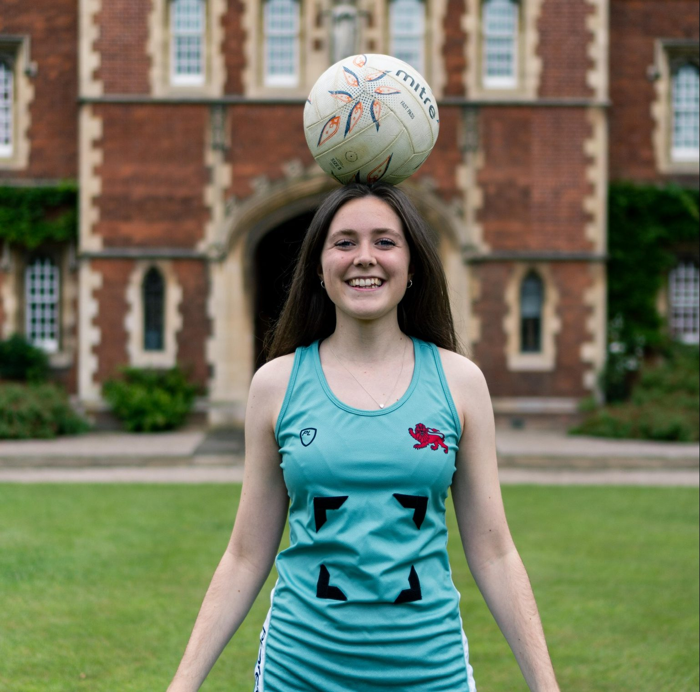
Email: if278@cam.ac.uk

The role of the Club Welfare Officer is to promote welfare centred practices within the club environment, provide a confidential, initial contact point for members in relation to welfare concerns and signpost individuals to relevant University, College and Community support systems when required. The role holder will:-

• Assist the club in developing policies and procedures that prioritises equality and the ongoing welfare of club members. This should include welfare and equality policies.
• Work with the Club Committee to ensure that Codes of Conduct are in place for club staff, volunteers, coaches and competitors.
• Be a confidential point of contact for any issues concerning welfare within the Sports Club environment, e.g. poor practice, selection policy concerns, training/competition pressures from captains, coaches or other members, potential/alleged bullying or harassment.
• Ensure that all incidents are reported correctly and referred, in accordance with the Club Welfare Policy and, where appropriate, Disciplinary Policy.
• Keep up to date with referral routes available to students within the University, College and local area and signpost members accordingly.
• Act independently and in the best interests of members of the club, putting their needs above that of others and the club itself.
• Be in attendance at Club Committee Meetings to advise on welfare matters.
• Ensure confidentiality is maintained and information is only shared on a ‘need to know’ basis and that information is only shared on a genuine ‘need to know’ basis;
Please note that it is NOT the role of the Club Welfare Officers to provide individual counselling support to club members. The Colleges work in close partnership with the University to provide the very best pastoral and welfare support to students and, as part of that partnership, individuals such as College Tutors and Senior Tutors have formal welfare roles and responsibilities and, as such, are better placed to provide guidance and support to students on non-sport specific welfare matters.
The University Counselling Service can provide individual counselling support for students in a range of areas, including anxiety, depression, academic related issues and relationships. In addition, Mental Health Advisors, working in the Counselling Service, can provide support and guidance to students who are in crisis or who are experiencing moderate to severe mental health difficulties. There are also a range of self-help guides, resources and information for students available on the University Counselling Service website at: https://www.counselling.cam.ac.uk/
CLUB POLICIES AND PROCEDURES
CULNC recognises the importance of having clear policies and procedures in place to support student welfare. Club Members should ensure that they read and adhere to the following policies and procedures:-
Policies | Web Link
Financial support | - If you are experiencing money worries, please do talk to any member of the club committee or who can provide information on where to find further help:  - A number of Colleges have funds available to support students playing at a University Sport Level. Students should speak to the College Tutor to see what is available and when application deadlines occur.  - The Eric Evans Fund is available for students to apply for small funding amounts to support high level performance or coaching/officiating courses: http://www.sport.cam.ac.uk/student-sport/bursaries-and-scholarships.  - The Hawks’ and Ospreys also have various bursary funds available for students and teams to apply for: https://www.hawksclub.co.uk/trust/about-the-trust/.  - The TASS scheme may be available for students identified by their NGB. More information on the scheme and eligibility is available at: www.tass.gov.uk.
Equality Policy | CULNC respects the rights, dignity and worth of every person involved in its activities. CULNC is committed to team members enjoying Netball in an environment free from discrimination, intimidation, harassment and abuse. CULNC believes that it is the responsibility of all of its members to challenge discriminatory behaviour and promote equality of opportunity. Every person, regardless of race, sex, gender identity, national origin, colour, disability, age, sexual orientation, marital status, religion or any other status protected by law, will be a welcome and valued member of the club.
Selection Procedure | - Players are selected through trials held at the start of Michaelmas. There are two stages in this process: the first is a 3-hour session for those who have not been part of CULNC before. Those successful will be invited to the second round where they will trial with existing CULNC members. Decisions are made by our coaches and the club captain. Selected teams will be announced on the club website after the second round of trials.  - The starting seven for weekly matches is selected after Monday training for Blues and Jays, and Sunday training for Swallows. Teams are announced via email from the Club Captain.  - Varsity selection is based on performance throughout the season. The decision is collaborative: made by our coaches and the club and team captains.  - For all teams the starting seven is announced a few days prior to the match via phone call from the team captain.

The Sports Service has a number of staff available to support Clubs in setting up a positive welfare culture supported by clear policies and procedures. The Sports Service Welfare Officers are also available to students if they feel unable to speak to their Club Welfare Officer or College Tutor regarding sports related matters.

Sports Service Welfare Officer | Sports Service Welfare Officer | Welfare@Sport Strategic Lead
Tristan Coles Head of Fitness, S&C  Tel: 01223 768215 welfare@sport.cam.ac.uk   | Lucy McGennity Sports Club Project Coordinator  Tel: 01223 336997 welfare@sport.cam.ac.uk   | Karen Pearce Assistant Director of Sport  Tel: 01223 762954 karen.pearce@sport.cam.ac.uk

